Dear Students & Parents,
Greetings from Global Olympiads Academy (G.O.A.)!
Together with your child’s school, we invite your child to participate in International Olympiads from South East Asian countries like Singapore and Hong Kong which are organized and conducted by us in India. This is an excellent opportunity for the kids to get exposure to truly international competitions which focus on problem solving and higher order thinking skills.
Please visit our website www.globalolympiadsacademy.com where you will find many international competitions to choose from for your child and then register through your school.
Hong Kong International Mathematical Olympiad (HKIMO)
(Website: www.hongkongimo.com )
Grades: KG to 12 (2018-19)
April end / May 1st Week 2019 in your school or Online
Fees: INR 1000
Registration ends: 20th April

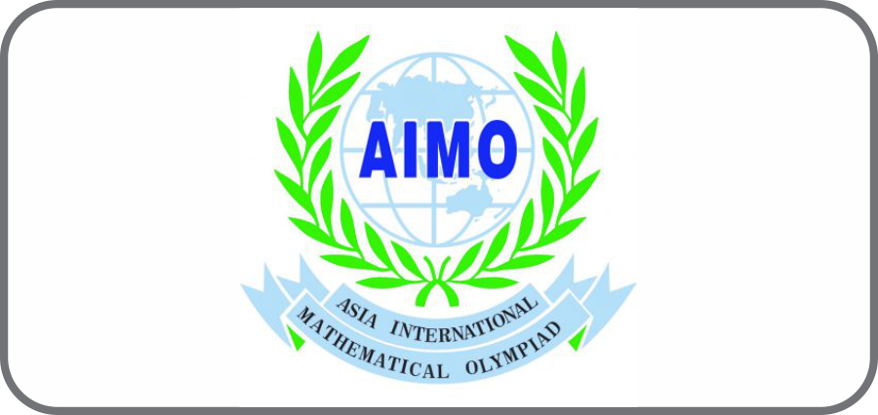
Asia International Mathematical Olympiad (AIMO)
(Website: www.aimo.world)
Grades: 3 to 12 (2018-19)
March end / April 1st week 2019 ONLINE
Fees: INR 800
Registration ends: 16th March 2019

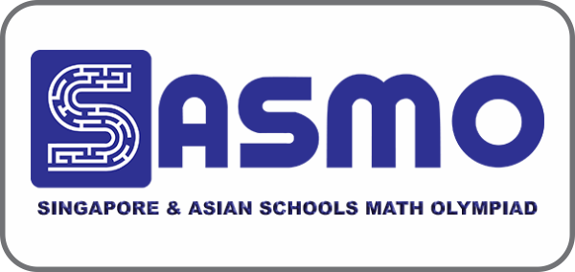
Singapore and Asian Schools Math Olympiad (SASMO)
(website: www.sasmo.sg)
Grades: 2 to 11 (2018-19)
2nd and 3rd week of April 2019 in your school.
Fees: INR 1200
Registration ends: 16th March 2019

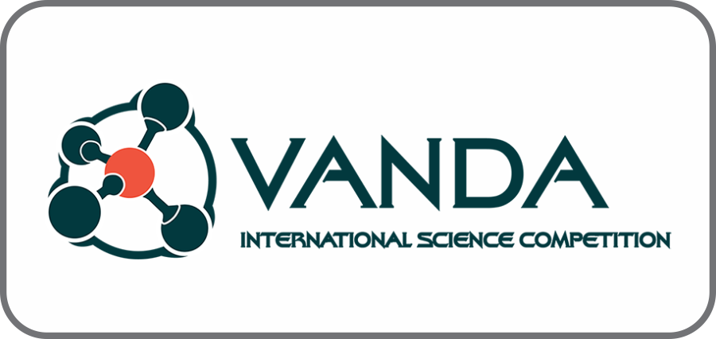
VANDA – International Science Competition
(Website: www.vanda.sg)
Grades: 3 to 10 (2018-19)
4th week of April 2019 in your school.
Fees: INR 1200
Registration ends: 31st March 2019.

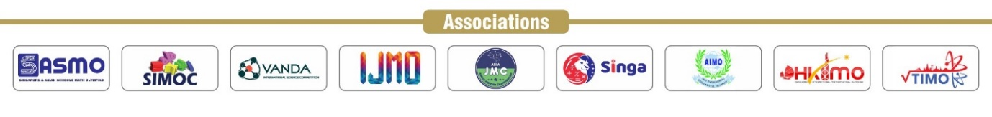

Other competitions (to be held in 2nd Half of 2019):
Singapore International Math Olympiad Challenge (SIMOC): SASMO winners will be eligible to compete at this global level contest in Singapore in early July 2019. Registrations to open in May after SASMO results. Website: www.simoc.sg
International Junior Math Olympiad (IJMO): SASMO Gold and Silver medal winners will be eligible to compete in this Global contest, most likely to be held in Malaysia in July end 2019. Registrations to open in May after SASMO results. Website: www.ijmo.asia
SINGA: Singa is a team competition held in November in a South East Asian location where teams of 3 compete in a collaborative Math challenge competition. Registrations will open after July 2019. Website: www.singamath.com
Thailand International Mathematical Olympiad (TIMO): TIMO heats were conducted recently in Oct 2018 and the Finals is being conducted in Phuket, Thailand in April 1st week. 60 students have qualified to register for TIMO finals.
TIMO Finals and HKIMO Finals Gold Winners are eligible to participate in WIMO in Japan, December Next Year. Website: www.thaiimo.com
The World Mathematics Championships® are collaborative assessment-as-learning experiences for all youths yet to commence university study.
Website: www.competition.ac

Registration Form for Students registering through school.
Full name (first name first) in capital letters of the student | Class and Section (as per 2018-19) | Date of Birth (dd/mm/yyyy format) | Gender
 |  |  | M F
Participating in: SASMO AIMO HKIMO VANDA
1200/- 800/- 1000/- 1200/-
Parent’s name: | Parent’s Mobile No. | Parent’s e-mail address:
Correspondence Address:
Visit our website for these competition details: www.globalolympiadsacademy.com
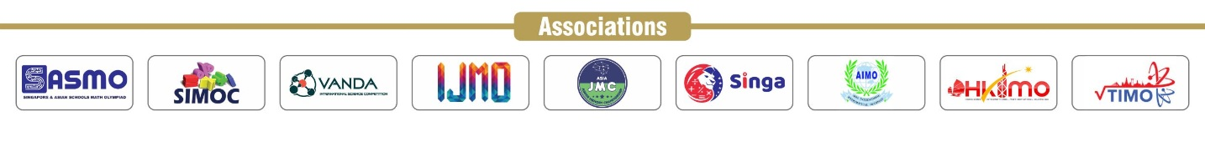
Please fill in the form properly indicating correctly the competitions your child would be participating in. Please pay 1000/- per competition to your school in Cash/Cheque (as instructed by your school). Please note that the fees for students registering through school is discounted. Preparation material in the form of more practice/past papers will be shared with school after registrations in soft copy which the school will share with you.
Visit www.globalolympiadsacademy.com for more details.

