Dear Students & Parents,
Greetings from Global Olympiads Academy (G.O.A.)!
Together with your child’s school, we invite your child to participate in International Olympiads from South East Asian countries like Singapore and Hong Kong which are organized and conducted by us in India. This is an excellent opportunity for the kids to get exposure to truly international competitions which focus on problem solving and higher order thinking skills.
Please visit our website www.globalolympiadsacademy.com where you will find many international competitions to choose from for your child and then register through your school or register individually from our website: www.globalolympiadsacademy.com for all competitions except SEAMO where you can sign up directly as www.seamo-official.org
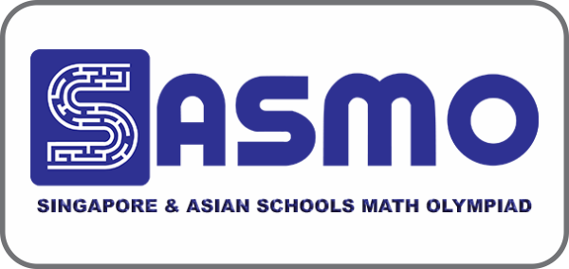
Singapore and Asian Schools Math Olympiad (SASMO)
(website: www.sasmo.sg)
Grades: 2 to 11 (2019-20)
Online from home by August end 2020 weekends.
Fees: INR 1200
Registration ends: 22nd July 2020
Next Round: SIMOC (Online) in October 2020 for all SASMO winners and IJMO (only for Gold & Silver in SASMO) in December 2020 (Online).

VANDA – International Science Competition
(Website: www.vanda.sg)
Grades: 3 to 10 (2019-20)
Online from home by August / September 2020 weekends.
Fees: INR 1200
Registration ends: 22nd July 2020
Next Round: Vanda Global Finals in October 2020 for all Vanda winners will be held Online

International Singapore Maths Competition (ISMC)
(Website: www.ismc.sg)
Grades: 2 to 6 (2019-20)
Online from home in October 2020 end weekends.
Fees: INR 1000 (schools) / 1200 (private)
Registration ends: September 30, 2020.

Southeast Asia Mathematical Olympiad (SEAMO)
(Website: www.seamo-official.org)
Grades: 1 to 12 (2019-20)
Online from home on 27 Sept / 4 Oct 2020
Fees: SGD 12/ INR 650
Registration ends: September 04, 2020 (Register at SEAMO website)
Next Round: SEAMOX will be Online in January 2021 for SEAMO

Hong Kong International Mathematical Olympiad (HKIMO)
(Website: www.hongkongimo.com )
Grades: KG to 12 (2019-20)
Heats Round (Country level) Online from home on June 27, 2020
Fees: INR 1000 (schools) / 1200 (private)
Registration ends: June 21, 2020
Next Round: HKIMO Finals in Aug/Sept will be Online for Heats round winners.
Thailand International Mathematical Olympiad (TIMO)
(Website: www.thaiimo.com )
Grades: KG to 12 (2020-21)
Heats Round (Country level) Online from home in Oct-Nov 2020 over weekends
Fees: INR 1000 (schools) / 1200 (private)
Registration ends: September 30, 2020
Next Round: TIMO Finals in April 2021 for Heats round winners in Thailand.

Registration Form for Students registering through school.
Full name (first name first) in capital letters of the student | Class and Section (as per 2019-20) | Date of Birth (dd/mm/yyyy format) | Gender
 | 2019-20 Grade: |  | M F
 | 2020-21 Grade(for TIMO only):
Participating in: HKIMO (1000/-) TIMO (1000/-) SEAMO (650/-) ISMC (1000/-)

SASMO (1200/-) VANDA (Science) (1200/-)

Parent’s name: | Parent’s Mobile No. | Parent’s e-mail address:
Correspondence Address:

Visit the website for these competition details: www.globalolympiadsacademy.com

Please fill in the form properly indicating correctly the competitions your child would be participating in. Please pay fees to your school in Cash/Cheque (as instructed by your school). Please note that the fees for students registering through school is discounted. Preparation material in the form of more practice/past papers will be shared with school after registrations in soft copy which the school will share with you.
Visit www.globalolympiadsacademy.com for more details. You may contact them directly for any inquiries at info@globalolympiadsacademy.com or Mr. Debraj Chakravarty at +91-9833916024.

